Chapter 3, Solution 46

Calculate the mesh currents i₁ and i₂ in Fig. 3.92.

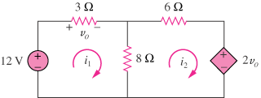

Figure 3.92
For Prob. 3.46.

Solution

For loop 1,
(1)
For loop 2,
But ,
(2)
Substituting (2) into (1),
A and A

